Contents

Heart Attack Chances Prediction Model 1

Introduction: We are going to build a model to predict the chances of having heart attack among people with 1

with the following symptoms: 1

Chest Pain: Discomfort in the chest including a dull ache, a crushing or burning feeling, a sharp stabbing pain and pain that radiates to the neck or shoulder. 1

Types of Chest Pain 1

i> Angina 1

ii> Typical Angina 1

iii> Atypical Angina 1

iv> Non-Anginal chest pain 1

v> Asymtomatic chest pain 1

Objective: The objective of the model is to predict the chances of having heart attack among human beings 7

with the above mentioned criterions based on the given dataset for heart attack with utmost accuracy. 7

Let’s define the above mentioned factors which can directly or indirectly affect our chances of having a heart attack. 7

Angina: Is the discomfort/uneasiness in chest.There are four types of Angina which are as follows: 7

8

a> Typical Angina: Is the high sensation of chest pain. 8

b> Atypical Angina: Is when there is non-cardiac chest pain.It implies that the complaints is actually Angina pecto-risk not confirming in every way to the expected or classic description, non-cardiac chest pain implies confidence that the problem does not rest with the heart whereas Atypical Angina says there is something in or about. 9

c> Non-Anginal chest pain: Is a term used to describe chest pain that resembles heart pain in patients who do not have heart disease. 9

The pain is typically felt behind the breast bone (Sternum) and is described oppressive, squeezing or pressure like. 9

d> Asymptomatic Chest Pain: Defined as the typical E.C.G. changes recorded on an ambulatory E.C.G. monitoring depicting underlying ischemia 9

# with absence of Angina symptoms. 9

Trestbps: Resting blood pressure. According to modern research if anyone is having more blood pressure then there would be more no. of blood vessels in the heart which could lead to clotting of blood in the heart or in the stain. 9

9

vii> Cholesterol: Is an important ingredient in our body which produces fatty cells in our body. There are two types of cholesterol : 9

Good Cholesterol (H.D.L.) 9

Bad Cholesterol (L.D.L.) 9

Cholesterol Range>200 mg/dl means high chances of having a heart attack. 10

10

viii> F.B.S.: Fasting blood sugar 10

Normal Range: 100-125 mg/dl 10

10

ix> Rest E.C.G.: Maximum heart rate achieved by exercising. 10

11

x> Thalach: Separate two levels of target features. So healthy people have a quite higher maximum heart rate of 160 compared to the maximum heart rate of 150 of patients with heart disease. 11

11

xi> Old Peak: Exercise related to rest (old peak) the slope of the peak. Exercise ST segment (Slope) no. of major vessels coloured by fluoroscopy and thalassemia. It is a prediction of heart disease. 12

13

xii> Exang: Exercise induced Angina. Stable Angina is usually triggered by physical activity like when you climb stairs, exercise or work your heart demands more blood but narrowed arteries slow down the blood flow. It is called Exang. 13

xiii> Thalassemia: It is a blood disorder. The heart cannot pump enough blood. 13

14

xiv> Slope: The ST segment merge due to excessive exercise. The ST segment shift relative to exercise induced increments in heart rate. The ST/heart rate slope expressed as a more accurate E.C.G. criterion for diagnosing significant coronary artery disease. 14

14

xv> Ca-coronary artery: Major vessels at heart aorta. 14

15

Superior venacava 15

Inferior venacava 15

Pulmonary veins and arteries 15

Coronary arteries 15

Features 16

Description 16

Data type 16

Sex 16

1=Male,0=Female 16

Categorical 16

Chest Pain 16

Chest Pain 16

Categorical 16

Angina 16

Is the discomfort/uneasiness in chest. 16

Categorical 16

Typical Angina 16

Is the high sensation of chest pain. 16

Categorical 16

Atypical Angina 16

Is when there is non-cardiac chest pain. 16

Categorical 16

Non-Anginal Chest Pain 16

Is a term used to describe chest pain that resembles heart pain in patients who do not have heart disease. 16

Categorical 16

Asymptomatic Chest Pain 16

Defined as the typical E.C.G. changes recorded on an ambulatory E.C.G. monitoring depicting underlying ischemia with absence of Angina symptoms. 16

Categorical 16

Trestbps 17

Resting blood pressure. According to modern research if anyone is having more blood pressure then there would be more no. of blood vessels in the heart which could lead to clotting of blood in the heart or in the stain. 17

continious 17

Cholestrol 17

: Is an important ingredient in our body which produces fatty cells in our body. There are two types of cholesterol : 17

Good Cholesterol (H.D.L.) 17

Bad Cholesterol (L.D.L.) 17

continious 17

FBS 17

Fasting blood sugar 17

Normal Range: 100-125 mg/dl 17

continious 17

Old peak 17

Exercise related to rest (old peak) the slope of the peak. Exercise ST segment (Slope) no. of major vessels coloured by fluoroscopy and thalassemia. It is a prediction of heart disease. 17

continious 17

Thalach 18

Separate two levels of target features. So healthy people have a quite higher maximum heart rate of 160 compared to the maximum heart rate of 150 of patients with heart disease. 18

continious 18

Exang 18

Exercise induced Angina. Stable Angina is usually triggered by physical activity like when you climb stairs, exercise or work your heart demands more blood but narrowed arteries slow down the blood flow. It is called Exang. 18

categorical 18

Thalassemia 18

It is a blood disorder. The heart cannot pump enough blood. 18

categorical 18

Slope 19

The ST segment merge due to excessive exercise. The ST segment shift relative to exercise induced increments in heart rate. The ST/heart rate slope expressed as a more accurate E.C.G. criterion for diagnosing significant coronary artery disease. 19

categorical 19

Ca-Coronary artery 19

Major vessels at heart aorta. 19

Superior venacava 19

Inferior venacava 19

Pulmonary veins and arteries 19

Coronary arteries 19

numerical 19

Heart Attack Chances Prediction Model

Introduction: We are going to build a model to predict the chances of having heart attack among people with

With the following symptoms:

Chest Pain: Discomfort in the chest including a dull ache, a crushing or burning feeling, a sharp stabbing pain and pain that radiates to the neck or shoulder.

Types of Chest Pain

i> Typical Angina

ii> Atypical Angina

iii> Non-Angina chest pain

v> Asymptomatic chest pain

Objective: The objective of the model is to predict the chances of having heart attack among human beings

With the above mentioned criterions based on the given dataset for heart attack with utmost accuracy.

Let’s define the above mentioned factors which can directly or indirectly affect our chances of having a heart attack.

Angina: Is the discomfort/uneasiness in chest. There are four types of Angina which are as follows:

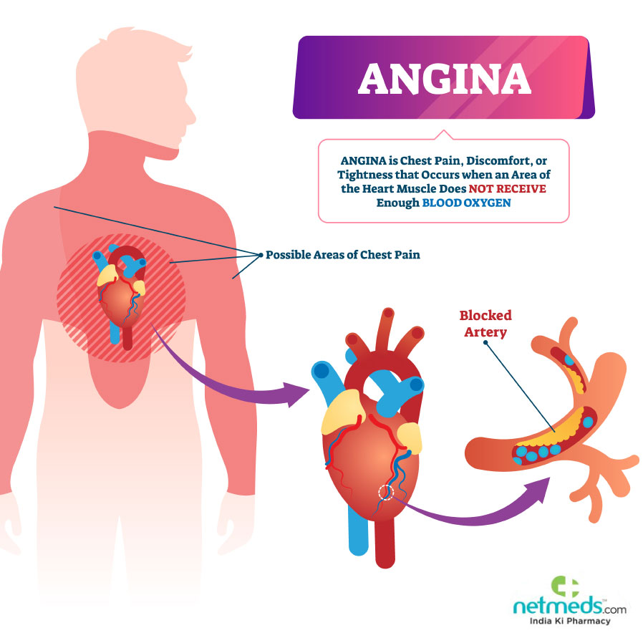

a> Typical Angina: Is the high sensation of chest pain.

b> Atypical Angina: Is when there is non-cardiac chest pain.It implies that the complaints is actually Angina pecto-risk not confirming in every way to the expected or classic description, non-cardiac chest pain implies confidence that the problem does not rest with the heart whereas Atypical Angina says there is something in or about.

c> Non-Anginal chest pain: Is a term used to describe chest pain that resembles heart pain in patients who do not have heart disease.

The pain is typically felt behind the breast bone (Sternum) and is described oppressive, squeezing or pressure like.

d> Asymptomatic Chest Pain: Defined as the typical E.C.G. changes recorded on an ambulatory E.C.G. monitoring depicting underlying ischemia

With absence of Angina symptoms.

Trestbps: Resting blood pressure. According to modern research if anyone is having more blood pressure then there would be more no. of blood vessels in the heart which could lead to clotting of blood in the heart or in the stain.

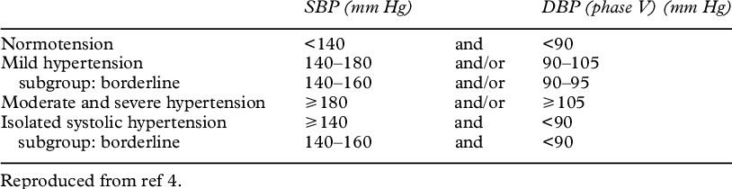

vii> Cholesterol: Is an important ingredient in our body which produces fatty cells in our body. There are two types of cholesterol :

Good Cholesterol (H.D.L.)

Bad Cholesterol (L.D.L.)

Cholesterol Range>200 mg/dl means high chances of having a heart attack.

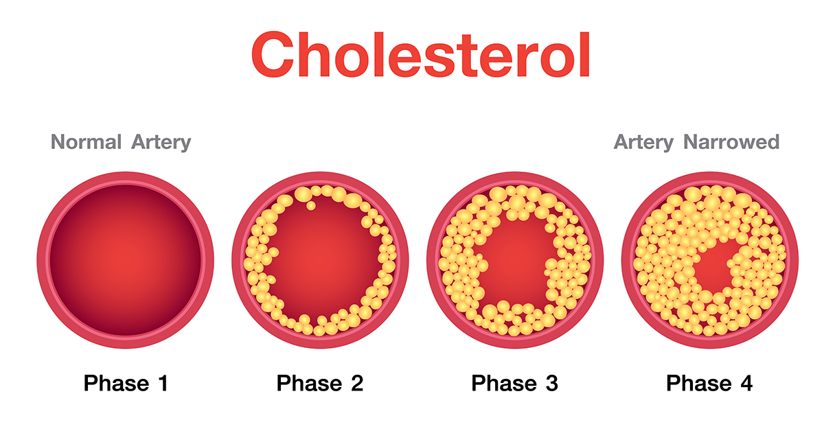

viii> F.B.S.: Fasting blood sugar

Normal Range: 100-125 mg/dl

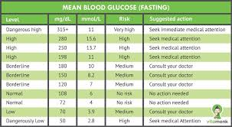

ix> Rest E.C.G.: Maximum heart rate achieved by exercising.

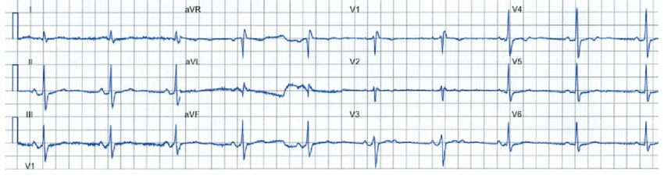

x> Thalach: Separate two levels of target features. So healthy people have a quite higher maximum heart rate of 160 compared to the maximum heart rate of 150 of patients with heart disease.

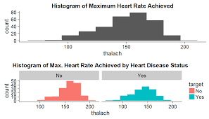

xi> Old Peak: Exercise related to rest (old peak) the slope of the peak. Exercise ST Segment (Slope) no. of major vessels coloured by fluoroscopy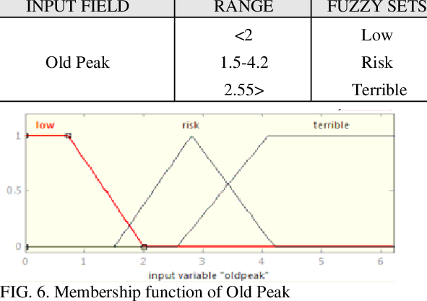py and thalassemia. It is a prediction of heart disease.

xii> Exang: Exercise induced Angina. Stable Angina is usually triggered by physical activity like when you climb stairs, exercise or work your heart demands more blood but narrowed arteries slow down t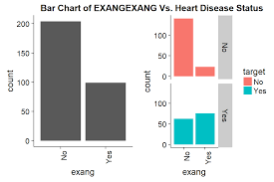he blood flow. It is called Exang.

xiii> Thalassemia: It is a blood disorder. The heart cannot pump enough blood.

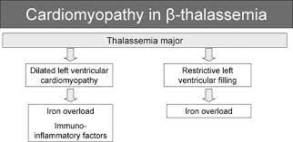

xiv> Slope: The ST segment merge due to excessive exercise. The ST segment shift relative to exercise induced increments in heart rate. The ST/heart rate slope expressed as a more accurate E.C.G. criterion for diagnosing significant coronary artery disease.

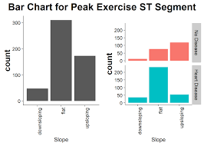

xv> Ca-coronary artery: Major vessels at heart aorta.

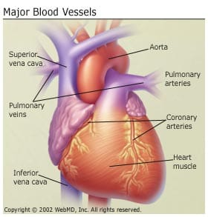

Superior venacava

Inferior venacava

Pulmonary veins and arteries

Coronary arteries

|  |  |  |
| --- | --- | --- |
| Features | Description | Data type |
| Sex | 1=Male,0=Female | Categorical |
| Chest Pain | Chest Pain | Categorical |
| Angina | Is the discomfort/uneasiness in chest. | Categorical |
| Typical Angina | Is the high sensation of chest pain. | Categorical |
| Atypical Angina | Is when there is non-cardiac chest pain. | Categorical |
| Non-Anginal Chest Pain | Is a term used to describe chest pain that resembles heart pain in patients who do not have heart disease. | Categorical |
| Asymptomatic Chest Pain | Defined as the typical E.C.G. changes recorded on an ambulatory E.C.G. monitoring depicting underlying ischemia with absence of Angina symptoms. | Categorical |
| Trestbps | Resting blood pressure. According to modern research if anyone is having more blood pressure then there would be more no. of blood vessels in the heart which could lead to clotting of blood in the heart or in the stain. | continuous |
| Cholestrol | : Is an important ingredient in our body which produces fatty cells in our body. There are two types of cholesterol :  Good Cholesterol (H.D.L.)  Bad Cholesterol (L.D.L.) | continuous |
| FBS | Fasting blood sugar  Normal Range: 100-125 mg/dl | continuous |
| Old peak | Exercise related to rest (old peak) the slope of the peak. Exercise ST segment (Slope) no. of major vessels coloured by fluoroscopy and thalassemia. It is a prediction of heart disease. | continuous |
| Thalach | Separate two levels of target features. So healthy people have a quite higher maximum heart rate of 160 compared to the maximum heart rate of 150 of patients with heart disease. | continuous |
| Exang | Exercise induced Angina. Stable Angina is usually triggered by physical activity like when you climb stairs, exercise or work your heart demands more blood but narrowed arteries slow down the blood flow. It is called Exang. | categorical |
| Thalassemia | It is a blood disorder. The heart cannot pump enough blood. | categorical |
| Slope | The ST segment merge due to excessive exercise. The ST segment shift relative to exercise induced increments in heart rate. The ST/heart rate slope expressed as a more accurate E.C.G. criterion for diagnosing significant coronary artery disease. | categorical |
| Ca-Coronary artery | Major vessels at heart aorta.  Superior venacava  Inferior venacava  Pulmonary veins and arteries  Coronary arteries | numerical |